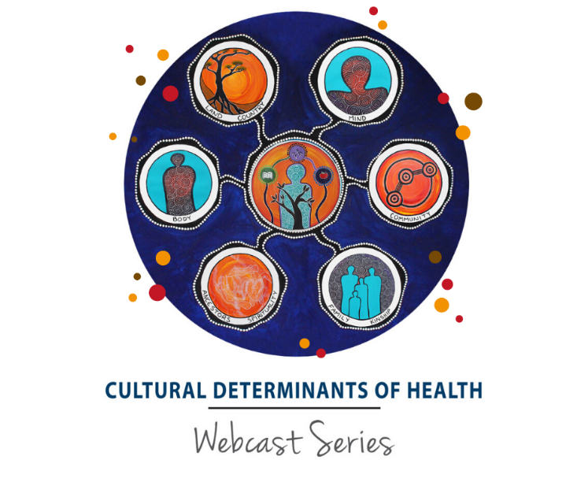
JOIN US FOR ONLINE WEBINAR

Friday 21 April
12:00pm – 1:30pm

Join us for lunch in as we watch:
Cultural Determinants of Health Webcast 2: Connection to Land and Country
Where: [ENTER LOCATION HERE]
RSVP to: [ENTER NAME & EMAIL ADDRESS]
Please bring something healthy to share.

ABOUT THE WEBCAST
Connection to land and Country respects values, places, resources, stories and cultural obligations associated with that area and its features. It describes the entirety of ancestral domains. Connection to land and Country is therefore essential to the continued cultural survival of Indigenous Australians as well as their economic and social development.
Topics discussed will include:
- Qualitative research on Aboriginal peoples’ relationship to their traditional land
- Disciplines that illuminate an understanding of the significance of contact with the natural world
- Governmental policies and practices that respect the right of First Nations peoples to self-determination and improvement of their social and economic conditions
- Ceremony and everyday cultural praxis
WHO’S ON THE PANEL?
Professor Kerry Arabena, Director Karabena Consultancy & Chair of Indigenous Health and Director of Onemda VicHealth Koori Health Unit at the University of Melbourne
Professor Tony Dreise, Director, Centre for Aboriginal Economic Policy Research
Benita Clements, Artist
Associate Professor Chelsea Bond, Aboriginal and Torres Strait Islander Studies Unit, University of Queensland
Alex Parmington, CEO, Wurundjeri Woi-wurrung Cultural Heritage Aboriginal Corporation

