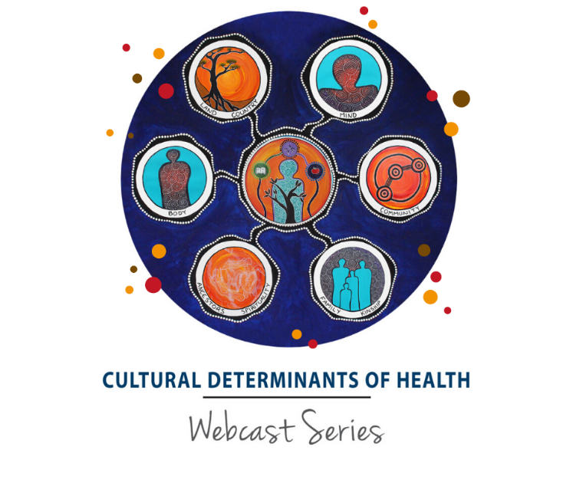
JOIN US FOR ONLINE WEBINAR

Friday 23 April
12:00pm – 1:30pm

Join us for lunch in as we watch:
Cultural Determinants of Health Webcast 1: A Framework for Action
Where: [ENTER LOCATION HERE]
RSVP to: [ENTER NAME & EMAIL ADDRESS]
Please bring something healthy to share.

ABOUT THE WEBCAST
This first webcast in a 5-part online series will explore cultural determinants of health as a conceptual framework for action. A panel of experts will explore themes related to questions of strategy, governance, tools and capacity building. Panellists will review experiences with an eye to understanding practice, innovations, and encouraging frank debate on the connections between health and Indigenous culture.
What to expect:
- Historical truth telling
- Current directions in CDoH theory
- Pathways and mechanisms through which CDoH influence health and wellbeing
- Purpose of constructing a framework for the CDoH

WHO’S ON THE PANEL?
Professor Kerry Arabena, Director Karabena Consultancy & Chair of Indigenous Health and Director of Onemda VicHealth Koori Health Unit at the University of Melbourne
Wes Morris, Coordinator, Kimberley Aboriginal Law and Culture Centre (KALACC)
Richard Weston, Deputy Children’s Guardian for Aboriginal Children and Young People, Office of the Children’s Guardian
Professor Pat Dudgeon, School of Indigenous Studies, University of Western Australia
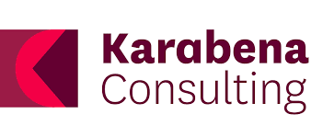
Joanne Richardson, Manager, Koori Courts

